Class 3, single inheritance, Muliple, Insertion sort, Selection sort, 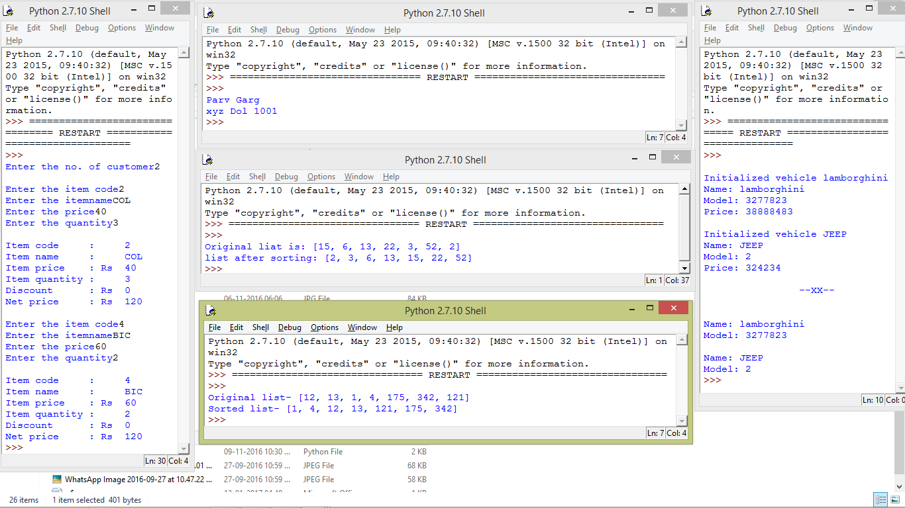

Composite, 3 and 5, 5th position

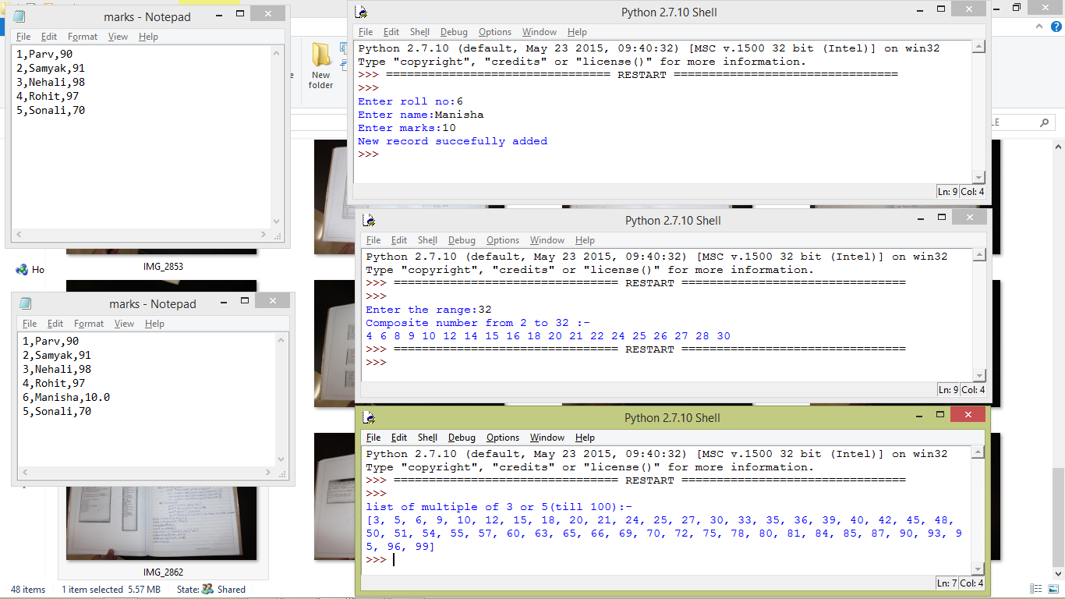

Fabo,linear, binary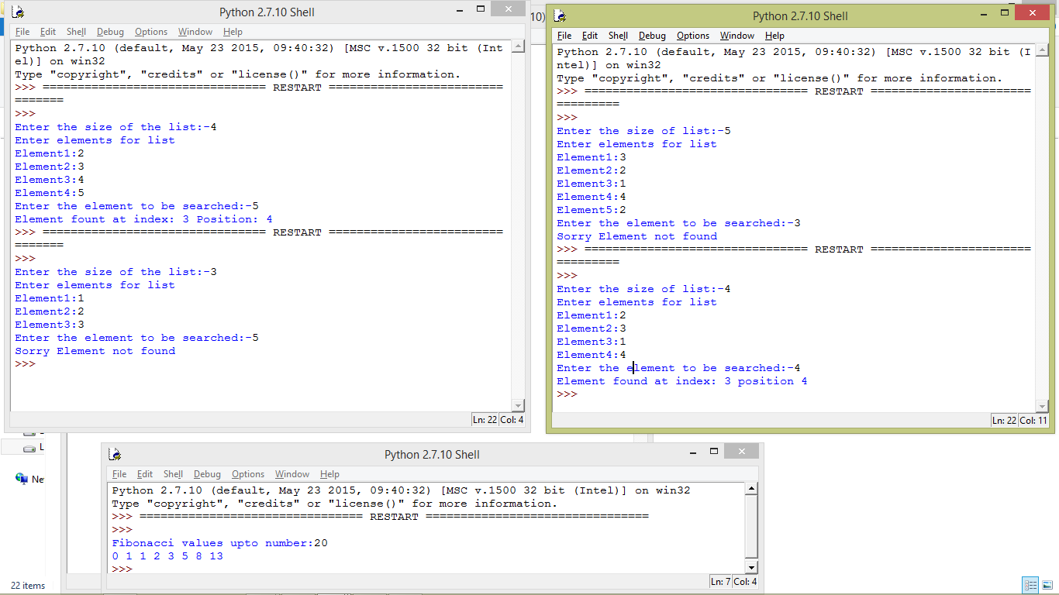

Pickle

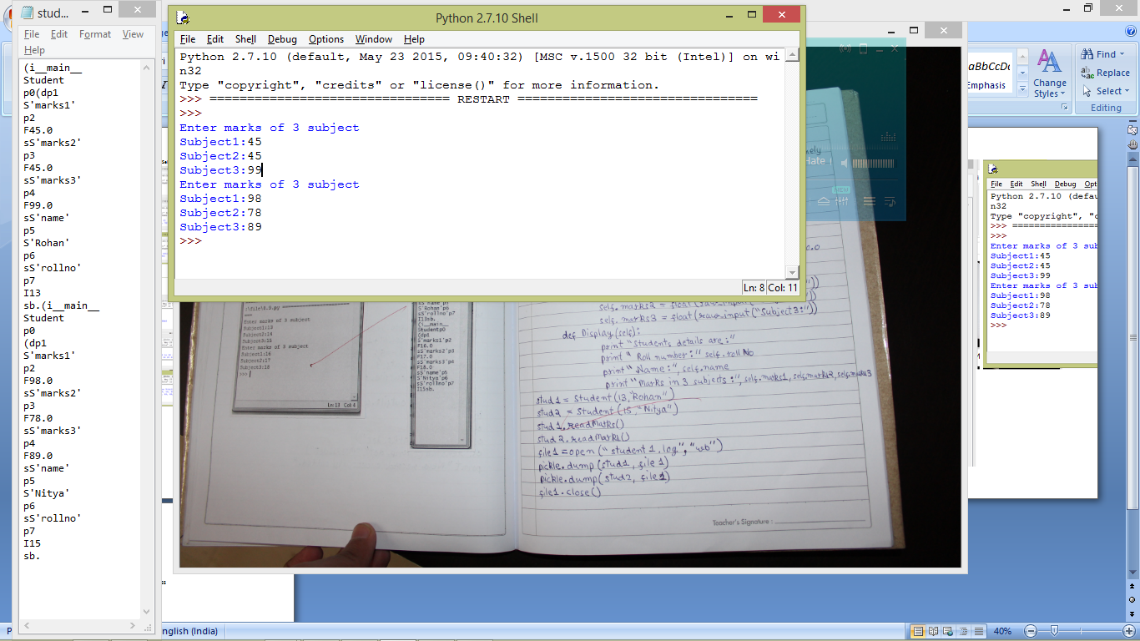

LEFT LINEAR SEARCH, BINARY SEARCH, TIME CLASS